Source: J. Mullahy (1997), “Instrumental-Variable Estimation of Count Data Models: Applications to Models of Cigarette Smoking Behavior,” Review of Economics and Statistics 79, 596-593. Professor Mullahy kindly provided the data. He obtained them from the 1988 National Health Interview Survey. The following model have found in the Wooldridge book (Wooldridge, pages: chapter 7, example 7.7, page: 231)
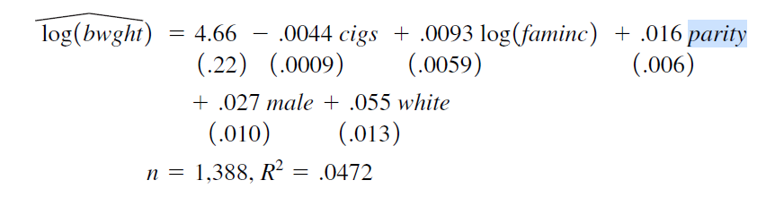
Explaining the theory behind my model
From the above equation, I have selected some variables to construct my model. My regression equation looks as follows:
$$\hat{log⁡(bwght)}= β_{0} + β_{1}cigs+β_{2}log⁡(faminc)+ β_{3}parity+β_{4}male+ \hat{u}$$
Here in the model,
Dependent variable
- lbwght: log of birth weight, ounces
Independent variables
- cigs: cigs smked per day while preg
- lfaminc: log of 1988 family income, $1000s
- parity: birth order of child
- male: =1 if male child
In this model, I am going to estimate the linear relationship between child’s birth weight and cigs, faminc, parity, male, by using OLS method. Generally we know cigs is harmful for body, so if a woman smoked during pregnancy time, how much it impact the birth weight? Does birth weight depend on family income? If the birth order of child increases, does it impact on the next baby’s birth weight? Is there any difference between male and female infant’s birth weight? Based on these questions, my model can estimate birth weight.

Determine the functional form
One of the assumptions of the classical linear regression model (CLRM), Assumption 9, is that the regression model used in the analysis is “correctly” specified: If the model is not “correctly” specified, encounter the problem of model specification error or model specification bias. It can be happened for various reason. So, my regression equation looks as follows:
There are multiple ways to test the specification errors. Here, to determine the functional form, I am going to use Ramsey Reset test as suggested.
The steps involved in RESET are as follows: Assignment 16
1. From the chosen model, obtain the estimated result of lbwght, that is yhat.
2. Rerunning the regression Equation by introducing yhat_2, yhat_3, yhat_4 in some form as an additional regressors. Thus, we run,
3. Let obtained R2 from both equation and calculating F value by applying the following formula:
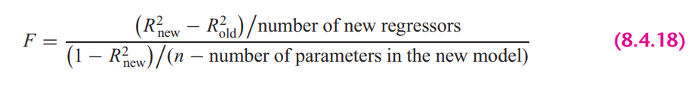
In STATA, the calculation looks as follows:

Rule: If the computed F value is significant, at the 5 percent level, one can accept the hypothesis that the model is mis-specified.
Findings: From the results we can see that, F value is insignificant at 5% percent significance level, therefore, we can not reject the hypothesis that the model is misspecified.

STATA version Ramsey rest test gives the following result:

It also suggest the same result. Here we cannot reject the null hypothesis (Model has no omitted variables) at 95% confidence level. So, from all of the test, we can conclude that, the chosen model is not misspecified.

Explaining the OLS equation
.
In STATA, by the following command, obtained regression result.

Findings from the result:
R-squared: R-Squared is the proportion of variance in the dependent variable (lbwght) which can be predicted from the independent variables (cigs, lfaminc, parity, male). This value indicates that only 3.5% of the variance in lavgsal can be predicted from the variables cigs, lfaminc, parity, male.
cigs: If cig smoking during pregnancy increase by 1 unit, will expect a decrease in birth weight by -0.004%, holding other variables constant. The variable is statistically significant at 5% significance level.
lfaminc: If family income increases by 1%, will expect an increase of birth weight by .018%, holding other variables constant. The variable is statistically significant at 5% significance level.
parity: If birth order of child increase by 1, will expect an increase in birth weight by .017 grade, holding other variables constant. The variable is statistically significant at 5% significance level.
male: Male baby weight is estimated to be higher by .026% than female baby weight, holding other variables constant. The variable is statistically significant at 5% significance level.
const: When all the explanatory variables value is 0, in average lbwght is 4.17

Heteroskedasticity test

A sequence of random variables is homoscedastic if all its random variables have the same finite variance. This is also known as homogeneity of variance. The complementary notion is called heteroscedasticity, where:

$$Var\left(u_{i}\right)≠ σ^{2}$$
Therefore, having an equal variance means that the disturbances are homoscedastic. However, it is quite common in regression analysis for this assumption to be violated. In this assignment, I am going to test heteroskedasticity by applying different methods.

- Graphical Method
Graphical method is also known as the informal way, is by inspection of different graphs. Heteroskedasticity can be detected by the scatter plot.
To plot the heteroskedasticity I have followed the following steps:
- Run the regression equation and obtained the residuals of this regression equation
- Plotting residuals against the regression fitted values by STATA built in command
Here, if we look at the residual plot against individual explanatory variable, it looks as follows
Findings
Its’ hard to reach any conclusion by looking at the graphical representation of residuals and fitted values or any explanatory variable. It doesn’t follow any exact pattern, so I think the variance is constant.

- Park test

- Run the regression of Equation and obtain the residuals (µ_{i}) of this regression equation.
- Run the following auxiliary regression:

Since, log of 0, can make a variable undefined. Therefore, I didn’t transform male variable to log(male).
$$\ln\left(\hat{u_{i}^{2}}\right)= α_{0} +α_{1 }\log\left(cigs\right)+α_{2}\log\left(faminc\right)+ α_{3}\log{(parity)}+α_{4} male+ e_{i}$$
- To interpret the auxiliary regression result, we need to formulate the null and the alternative hypotheses. The null hypothesis of homoskedasticity is:
$$H_{0}: { α}_{1}= α_{2}=…= α_{p}=0; Homoskekdasticity$$
$$H_{a}: any { α}_{p} ≠ 0; Heteroskedasticity$$
From the auxiliary regression, we can see all the explanatory variables are statistically insignificant therefore all the coefficient value is 0 at 95% confidence interval. Here, the alternative is that at least one of the a’s is different from zero, in this case all the variable a’s equal to zero. So, from the hypothesis assumption, we cannot reject the null hypothesis. Therefore, we can conclude that park test says, there are constant variance presence in the model.

- Computing the LM statistics (LM = nR²), where n is the number of observations used in order to estimate the auxiliary regression in Step 2, and R² is the coefficient of determination of this regression. The LM-statistic is distributed under a chi-square distribution with degrees of freedom equal to the number of slope coefficients included in the auxiliary regression (or k − 1), which in my case is 4 and significance level is 5%.

Findings from the Park Test
As we have seen at step 3 that we can reject the null hypothesis and also from the LM test we can see that, LM statistics is lower than the critical chi2 value. So, in this case we also cannot reject the null hypothesis of constant variance (presence of homoskedasticity).

- Glesjer test

The Glesjer test can be performed in STATA as follows:
- First, the regression equation model is estimated with OLS, using the command and predict (gen) command is used to obtain the residuals (u_{i})
- Run the following auxiliary regression:
$$\left|\hat{u_{i}}\right|= α_{0} +α_{1 }cigs+α_{2} lfaminc+ α_{3}parity+α_{4} male+ e_{i}$$
- To interpret the auxiliary regression result, formulate the null and the alternative hypotheses. The null hypothesis of homoskedasticity is:
$$H_{0}: { α}_{1}= α_{2}=…= α_{p}=0; Homoskekdasticity$$
$$H_{a}: any { α}_{p} ≠ 0; Heteroskedasticity$$
- From the auxiliary regression, we can see all the explanatory variables are statistically insignificant therefore all the coefficient value is 0 at 95% confidence interval. Here, the alternative is that at least one of the a’s is different from zero, in this case all the variable a’s equal to zero. So, from the hypothesis assumption, we cannot reject the null hypothesis. Therefore, we can conclude that park test says, there are constant variance presence in the model.
- Computing the LM statistics (LM = nR²), where n is the number of observations used in order to estimate the auxiliary regression in Step 2, and R² is the coefficient of determination of this regression. The LM-statistic follows the χ² (chi-square) distribution with p − 1 degrees of freedom.
Findings from the Glesjer Test
As we have seen at step 3 that we can reject the null hypothesis and also from the LM test we can see that, NR2 is smaller than the critical chi2 value. So, in this case we also cannot reject the null hypothesis of constant variance, which indicates the evidence of homoskedasticity.

- Gold field Quandt test

To detect the heteroskedasticity by gold field quandt test, involving the following steps:
- Sort the data according to the variable lfaminc.
- Breaking the sample into two different sub-samples. To choose the sub samples, the following formula can be applied:
$$c=Total observation/5$$
$$Sub sample size =(Total observation-c)/2$$

So, from the first and last, sample size is 556 by excluding the middle observations.

- Now run OLS for both sub-samples in order to obtain the Mean square of residual (RSS/df), using the following commands:

- Calculating F-statistics for Gold Quandt, F-critical and P-value as follows:

Findings from the Gold Field Quandt Test
Final conclusion can be made by comparing F-statistics and F-critical values. Since F-statistics is smaller than the F-critical value, which makes the F-stat statistically insignificant at 5% significance level, therefore we cannot reject the null hypothesis and it indicates the evidence heteroskedasticity.

- Breusch-Pagan Godfrey test

- Estimate Eq. by OLS and obtain the residuals
- Obtaining variance $σ^{2}$ of the regression by applying the following calculations in STATA
- Constructing variables P_{i} defined as
- Regress P_{i} thus constructed on the Z’s as
$$p_{i}= α_{0} +α_{1 }cigs+α_{2} lfaminc+ α_{3}parity+α_{4} male+ u_{i}$$

- Obtaining the ESS from the above regression result and defining theta as follows:
- Theta follows the chi-square distribution with (K − 1) degrees of freedom, so the chi² critical values with 4 degrees of freedom and 5% significance level as follows:
Findings from the Breusch-Pagan Godfrey Test
If in a model the computed THETA (= χ2) exceeds the critical χ2 value at the chosen level of significance, one can reject the hypothesis of homoscedasticity. Here from the result, we can see that THETA < chi², therefore it indicates the presence of homoskedasticity in the model.

- White’s general heteroskedasticity test

- The regression equation model is estimated with OLS, using the command to obtain the residuals (u_{i})
- Run the following auxiliary regression
Here, I have omitted male², since male is a dummy variable, adding square term of a dummy variable can create multicollinearity.
$$u_{i}^{2}= α_{0} +α_{1 }cigs+α_{2} lfaminc+ α_{3}parity+α_{4} male+ α_{5 }{cigs}^{2}+α_{6} {faminc}^{2}+ α_{7}{parity}^{2}+ u_{i}$$

- To interpret the auxiliary regression result, formulate the null and the alternative hypotheses. The null hypothesis of homoskedasticity is:
$$H_{0}: { α}_{1}= α_{2}=…= α_{p}=0; Homoskekdasticity$$
$$H_{a}: any { α}_{p} ≠ 0; Heteroskedasticity$$
- From the auxiliary regression, we can see all the explanatory variables are statistically insignificant therefore all the coefficient value is 0 at 95% confidence interval. Here, the alternative is that at least one of the a’s is different from zero, in this case all the variable a’s equal to zero. So, from the hypothesis assumption, we cannot reject the null hypothesis. Therefore, we can conclude that park test says, there are constant variance presence in the model.
- Computing the LM statistics (LM = nR²), where n is the number of observations used in order to estimate the auxiliary regression in Step 2, and R² is the coefficient of determination of this regression. The LM-statistic follows the χ² (chi-square) distribution with p − 1 degrees of freedom.

Findings from the white LM test
Final conclusion can be made by comparing the LM statistics and chi square critical value. Reject the null and conclude that there is significant evidence of heteroskedasticity when LM-statistical is greater than the critical value (LM-stat < χ2 _{7, 0.5}). In this case, I am going we cannot reject the null hypothesis of constant variance.

Autocorrelation test

One of the assumptions of the CLRM states that the covariances and correlations between different disturbances are all zero.
$$Cov\left(u_{i}, u_{j}\right)=0 for all i=j$$
This assumption states that the error terms $u_{i}$ and $u_{j}$ are independently distributed, termed serial independence. If this assumption is no longer true then the disturbances are not pairwise independent, but are pairwise autocorrelated.
In this situation:
$$Cov\left(u_{i}, u_{j}\right)≠0 for all i≠j$$
which means that an error occurring at period i may be correlated with one at period j.
In this assignment I am going to test autocorrelation by different approach.

- Graphical method to detect Autocorrelation

First the regression equation model is estimated with OLS, using the following command is used to obtain the residuals (u_{i})
Because our dataset includes cross-sectional data, we need to generate time variable to plot the residuals against time.
The following command is used to create the $u_{t-1}$ lagged series of residuals. Here uhat_lag1 is for the lag operator of first order.

Findings: Here, it’s hard to find any relationship by looking the scatter plot of $u_{t}$ against $u_{t-1}$, It seems like they have zero autocorrelatio.

- Runs test

A run is defined to be a succession of one or more identical symbols which are followed and proceeded be a different or no symbol at all.
In the run test the hypothesizes are,
$$H_{0}: no autocorrelation$$
$$H_{0}: autocorrelation$$
Here, by run test we find out how many times a positive trend became negative and how many times negative trend became positive by crossing mean or median value. For the error term threshold is 0.
To see the visual how many times the error term run positively and negatively across the time.

Findings: Here, we can see p-value is greater than 0.05 and we reject null hypothesis. So, run test says that the error terms are not autocorrelated.

- Durbin Watson test

In STATA, the following two steps required for Durbin Watson test:

- Estimate the model by using OLS
- Estimate DW test value by the following command

A rule of thumb for d-Watson test:
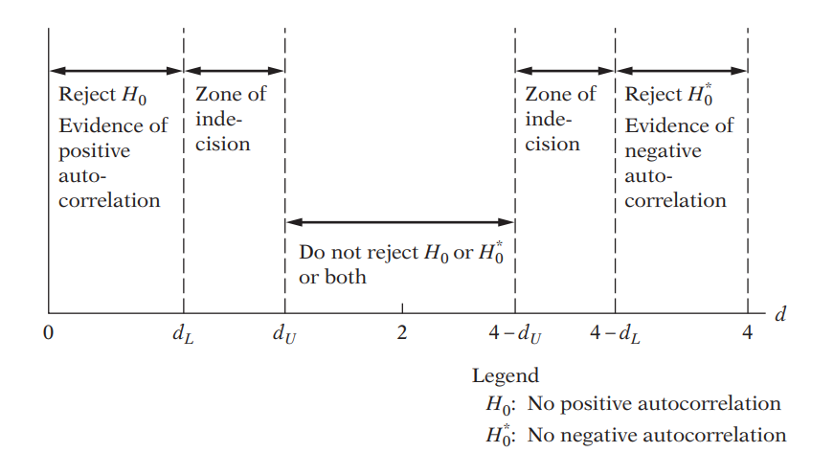
Findings: In my case, d-statistics is 1.93, which is close to 2. Therefore, according to Durbin Watson test, we don’t reject the null hypothesis and it has no autocorrelation.

- Breusch-Godfrey test

In the BG test, hypothesis are as follows:
$$H_{0}:Not autocorrelated, ρ_{1}=ρ_{2}={…=ρ}_{p}=0$$
$$H_{a}: Aotocorrelated, if any ρ≠0$$
Estimating the OLS and obtaining residuals
Here I am using 2 lags of orders to see the autocorrelation residuals and with its previous 2 lags

Moving Average equation looks as follows with 2 lags order:
$$u_{t}= p_{1}u_{t-1}+p_{2}u_{t-2}+ε_{t}$$

In Stata, the result looks as follows:
Findings: From the result, we can see both lags are statistically insignificant at 5% significance level means no lags can influence the current error term.
Findings from the LM test: Here we can see LM < chi2 critical value, therefore we cannot reject the null hypothesis and can conclude that the model has no autocorrelation
Same result from STATA built in bgodfrey test:

Multicollinearity test

11. The value of R-squared and t value

Findings
In this regression model, R squared is not too high, only 0.0350. If we look at t-statistics of the explanatory variables, we can see that all the t value is higher, where all of the variables are statistically significant at 95% confidence interval. In this case, we can say that there are no multicollinearity presents among the explanatory variables.

12. Pair-wise correlations among regressors

In STATA, by the following command we can get pair wise correlation value of the variables.

Findings
From the results, we can see that all the variables are pair wise correlated. But here none of the variables are highly pair wise correlated. Therefore, we can conclude that there isn’t enough pairwise correlation among regressors which can cause multicollinearity problem.

13. Auxiliary regression for multicollinearity

Since multicollinearity arises because one or more of the regressors are exact or approximately linear combinations of the other regressors, one way of finding out which X variable is related to other X variables is to regress each X_{i} on the remaining X variables and compute the corresponding R², which we designate as R²_{i}.
So, first auxiliary regression, where cigs is the dependent variable

Findings: If multicollinearity were presents, R square from the auxiliary regression would be very high but we can see it’s very low means that the variable is not collinear with other independent variables.

So, second auxiliary regression, where lfaminc is the dependent variable
Findings: If multicollinearity were presents, R square from the auxiliary regression would be very high but we can see it’s very low means that the variable is not collinear with other independent variables.

Third auxiliary regression, where male is the dependent variable

Findings: If multicollinearity were presents, R square from the auxiliary regression would be very high but we can see it’s very low means that the variable is not collinear with other independent variables.

14. Partial Correlations

In STATA, by the following command we can get partial correlation value of the variables
Findings: From the results, we can see that variables are very weekly partially correlated. But here none of the variables are highly partially correlated. Therefore, we can conclude that there isn’t enough partial correlation among regressors which can cause multicollinearity problem.
15. Condition Index

Conditional Index can be calculated as follows:

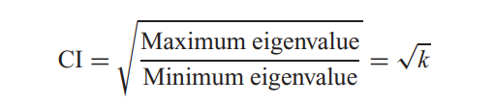
In STATA, by the following command, we can obtain the Eigenvalue and corresponding Conditional Index.

Rule of thumb: If k is between 100 and 1000 there is moderate to strong multicollinearity and if it exceeds 1000 there is severe multicollinearity. Alternatively, if the (CI = √k) is between 10 and 30, there is moderate to strong multicollinearity and if it exceeds 30 there is severe multicollinearity

Findings
From all of the observation, can see that Conditional index, Eigen value, VIF is very low for the explanatory variables. Therefore, we can conclude that, multicollinearity doesn’t exist among the regressors.

